**TRADITIONAL MARKETING**

**VS**

**DIGITAL MARKETING**

**A PROJECT REPORT**

**SUBMITTED IN PARTIAL FULFILLMENT OF THE REQUIREMENTS FOR THE AWARD OF**

**THE DEGREE OF**

**BACHELOR OF SCIENCE**

MATHEMATICS/STATISTICS

**SUBMITTED TO**

**DEPARTMENT OF MATHEMATICS& STATISTICS**

**SUBMITTED BY**

Name of Student(s) Roll No.

Mitali Agarwal 121418467021

Apoorva vatturi 121418467039

**SUPERVISED BY**

Mrs. S. VIJAYALAXMI

ASSISTANT PROFESSOR

August - 2021



**ST. JOSEPH’S DEGREE AND PG COLLEGE**

(An autonomous college of Osmania university)

5-9-1106, king koti main road, Hyderabad - 500029

**ABSTRACT**

We the students of St. Joseph’s Degree and PG College conducted a survey on Traditional marketing vs Digital marketing. This report summarizes the results of traditional marketing vs digital marketing. We received 1003 responses out of 1100 i.e.; 91.18%. The goal of our survey is to know which marketing people prefer more and why. This survey is carried out to study whether people are aware of both marketing or not. Mainly we focus which marketing is effective. Here we want to know what are the advantages and disadvantages of both marketing.

**ACKNOWLEDGEMENT**

We would like to express our special thanks to Mrs. S. Vijayalaxmi, Assistant professor, Department of Mathematics and Statistics for her stimulating guidance, continuous encouragement and supervision throughout the course as well as our Principal Rev.Fr. Marrareddy, who gave us an opportunity to do this project on the topic “Traditional Marketing VS Digital Marketing” which also helped in doing a lot of research and we came to know about so many new things and we are really thankful to them.

Secondly we would like to thank our friends and respondents (Business, Students, Government sector and Private sector employees) who helped us a lot in finalizing this project within limited time frame.

**SIGNATURE OF STUDENT (S)**

MITALI AGARWAL

APOORVA VATTURI

**TABLE OF CONTENTS**

Acknowledgement

Abstract

List of Tables

List of Figures

list of Abbreviations

List of Nomenclature

**CHAPTER 1: INTRODUCTION**

* 1. TRADITIONAL MARKETING
  2. DIGITAL MARKETING
  3. TRADITIONAL MARKETING VS DIGITAL MARKETING

**CHAPTER 2: HISTORY**

* 1. TRADITIONAL MARKETING
  2. DIGITAL MARKETING

**CHAPTER 3:** OVERVIEW OF THE PROJECT

**CHAPTER 4:** SUMMARY CONCLUSIONS

***chapter 5: summary executive***

**CHAPTER 6:** RECOMMENDATION

**LIST OF** TABLES

**TABLE TITLE**

3.1 Response on gender

3.2 Response on age group

3.3 Response on what method of shopping do the prefer

3.4 Response on have they ever made online shopping

3.5 Response on have they felt any problem on conducting online purchase

3.6 Response on what kind of problem

3.7 Response on reason for choosing online shopping

3.8 Response on reason for choosing offline shopping

3.9 Response on choose the product they prefer in online shopping

3.10 Response on choose the product they prefer in offline shopping

3.11 Response on do they have any concerns about data privacy while doing online shopping

3.12 Response on what is the satisfaction level while doing online shopping

3.13 Response on what is the satisfaction level while doing offline shopping

3.14 Response on which of the following is the most important factor while doing online shopping

3.15 Response on which of the following is the most important factor while doing offline shopping

3.16 Response on what type of product are you more likely buy in online shopping

3.17 Response on what type of product are you more likely buy in offline shopping

3.18 Response on Digital marketing has far more freedom of choice than a traditional marketing

3.19 Response on Branding ads through Social Media has More Reach than Television

3.20 Response on which marketing helped you in this pandemic situation

3.21 Response on for which shopping criteria they always like to do online payment

3.22 Response on online payment is not safe for shopping

3.23 Response on online shopping never guarantee about product

3.24 Response on which on is more effective

**LIST OF FIGURES**

**FIGURES**

3.1Frequency of gender

3.2Frequency of age

3.3 Response on what method of shopping do the prefer

3.4 Response on have they ever made online shopping

3.5 Response on have they felt any problem on conducting online purchase

3.6 Response on what kind of problem

3.7 Response on reason for choosing online shopping

3.8 Response on reason for choosing offline shopping

3.9 Response on choose the product they prefer in online shopping

3.10 Response on choose the product they prefer in offline shopping

3.11 Response on do they have any concerns about data privacy while doing online shopping

3.12 Response on what is the satisfaction level while doing online shopping

3.13 Response on what is the satisfaction level while doing offline shopping

3.14 Response on which of the following is the most important factor while doing online shopping

3.15 Response on which of the following is the most important factor while doing offline shopping

3.16 Response on what type of product are you more likely buy in online shopping

3.17 Response on what type of product are you more likely buy in offline shopping

3.18 Response on Digital marketing has far more freedom of choice than a traditional marketing

3.19 Response on Branding ads through Social Media has More Reach than Television

3.20 Response on which marketing helped you in this pandemic situation

3.21 Response on for which shopping criteria they always like to do online payment

**3.22 Response on online payment is not safe for shopping**

**3.23 Response on online shopping never guarantee about product**

**3.24 Response on which on is more effective**

**CHAPTER – 1: INTRODUCTION**

In marketing there are two types of marketing. First one is traditional marketing and the second one is digital marketing.

**TRADITIONAL MARKETING**

What traditional marketing actually mean? It means that the shopping which we personally go and buy the products which we need is called traditional marketing. In this marketing there will be no frauds and we can’t get any cheap quality product. Here we can choose products according to our budget and our taste. Here we can check the quality, we can see the fabric of clothes, we can try clothes, we can see whether the dress is looking good or not . There will be no money scams.

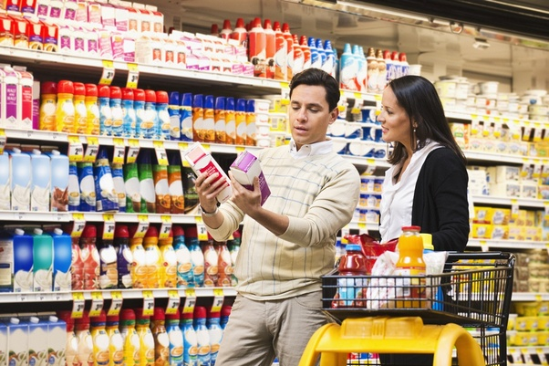

**DIGITAL MARKETING**

What digital marketing actually mean? **Online shopping** is the activity or action of buying products or services over the Internet. It means going online, landing on a seller’s website, selecting something, and arranging for its delivery. The buyer either pays for the good or service online with a credit or debit card or upon delivery. There are many disadvantages in this kind of shopping. Here we face money scams, there are more chances to get cheap quality, we may not get our product on time, it may not as same as we expect.



**TRADITIONAL MARKETING VS DIGITAL MARKETING**

|  |  |
| --- | --- |
| **TRADITIONAL MARKETING** | **DIGITAL MARKETING** |
| * The promotion of products and service through TV, telephone, banner, broadcast, door to door, sponsorship. | * The promotion of product and service through digital media or electronic medium like SEO, PPP etc. |
| * Traditional marketing is not cost effective. | * Digital marketing is more cost effective. |
| * Traditional marketing is not so good for brand building | * It is efficient and fast for brand building. |
| * Source of entertainment | * Complete product information |
| * Reliability, trust, security | * Accessibility, socialization, convenience |

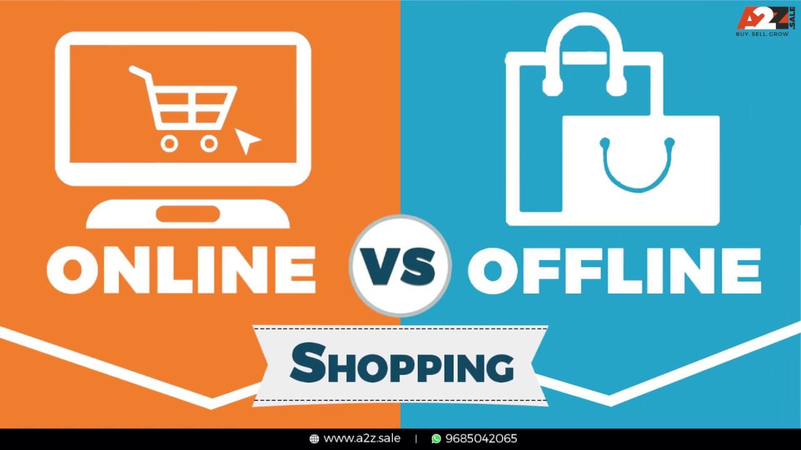

**CHAPTER 2: HISTORY**

TRADITIONAL MARKETING

The study of the **history of marketing**, as a discipline, is meaningful because it helps to define the baselines upon which change can be recognised and understand how the discipline evolves in response to those changes. The practice of [marketing](https://en.wikipedia.org/wiki/Marketing) has been known for millennia, but the term "marketing" used to describe commercial activities buying and selling a products or services came into popular use in the late nineteenth century. The study of the history of marketing as an academic field emerged in the early twentieth century.

Marketers tend to distinguish between the history of marketing practice and the history of marketing thought:

1. the *history of marketing practice* refers to an investigation into the ways that marketing has been practiced; and how those practices have evolved over time as they respond to changing socio-economic conditions
2. the *history of marketing thought* refers to an examination of the ways that marketing has been studied and taught

**MARKETING IN ENTIQUITY**

A number of studies have found evidence of advertising, branding, packaging and labelling in antiquity. Umbricius Scauras, for example, was a manufacturer of fish sauce (also known as [garum](https://en.wikipedia.org/wiki/Garum)) in Pompeii, circa 35 B.C. Mosaic patterns in the atrium of his house were decorated with images of [amphora](https://en.wikipedia.org/wiki/Amphora) bearing his personal brand and quality claims.

**MARKETING IN MIDDLE AGES**

 In England and Europe during the Middle Ages, market towns sprang up. Some analysts have suggested that the term, 'marketing,' may have first been used in the context of market towns where the term 'marketing' may have been used by producers to describe the process of carting and selling their produce and wares in market towns. Blintiff has investigated the early medieval networks of market towns and suggests that by the 12th century there was an upsurge in the number of market towns and the emergence of merchant circuits as traders bulked up surpluses from smaller regional, different day markets and resold them at the larger centralised market towns.

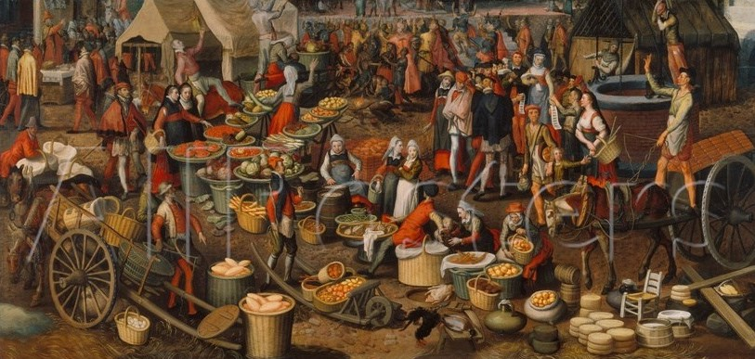

**MARKETING IN SEVENTEENTH AND EIGHTEENTH CENTURY**

Scholars have identified specific instances of marketing practices in England and Europe in the seventeenth and eighteenth centuries. As trade between countries or regions grew, companies required information on which to base business decisions. Individuals and companies carried out formal and informal research on trade conditions. As early as 1380, Johann [Fugger](https://en.wikipedia.org/wiki/Fugger) travelled from Augsburg to Graben in order to gather information on the international textile industry. He exchanged detailed letters on trade conditions in relevant areas. In the early 1700s British industrial houses were demanding information that could be used for business decisions. In the early 18th-century, [Daniel Defoe](https://en.wikipedia.org/wiki/Daniel_Defoe), a London merchant, published information on trade and economic resources of England and Scotland. Defoe was a prolific publisher and among his many publications are titles devoted to trade including; *Trade of Britain Stated,* 1707; *Trade of Scotland with France,* 1713 and *The Trade to India Critically and Calmly Considered,* 1720; all books that were highly popular with merchants and business houses of the period. While such activities might now be recognised as marketing research, at that time they were known as 'commercial research' or 'commercial intelligence' and not seen as part of the repertoire of activities that make up contemporary marketing practice.

**MARKETING IN NINTEENTH AND TWENTIETH CENTURY**

In the early twentieth century, as market size increased, it became more commonplace for manufacturers to produce a variety of models pitched at different quality points designed to meet the needs of various demographic and lifestyle market segments, giving rise to the widespread practice of market segmentation and product differentiation. Between 1902 -1910 George B Waldron, working at Mahin's advertising agency, used tax registers, city directories and census data to show advertisers the proportion of educated versus illiterate consumers and the earning capacity of different occupations in what is believed to be the first example of demographic segmentation of a population. Within little more than a decade, Paul Cherington had developed the 'ABCD' household typology - the first socio-demographic segmentation tool. By the 1930s, market researchers such as [Ernest Dichter](https://en.wikipedia.org/wiki/Ernest_Dichter) were carrying out qualitative research into brand purchasers realised that demographic factors alone were insufficient to explain different marketing behaviour of various user groups. This insight led to the exploration of other factors such as lifestyles, values, attitudes and beliefs in market segmentation and advertising.

When Wendell R. Smith published his now classic article, *Product Differentiation and Market Segmentation as Alternative Marketing Strategies* in 1956, he noted that he was simply documenting marketing practices that had been observed for some time and which he described as a "natural force". Other theorists agree that Smith was simply codifying implicit

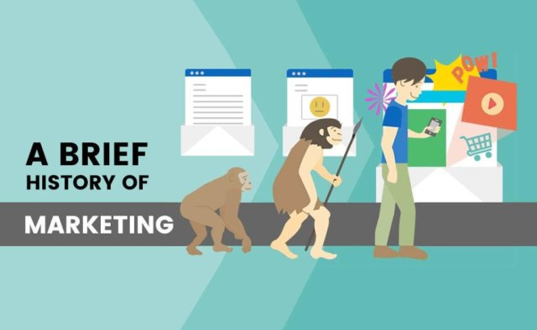

**HISTORY OF DIGITAL MARKETING**

In a world where over 170 million people use social media on a regular basis, every working professional is expected to be familiar with at least the core tenets of [Digital Marketing](https://www.simplilearn.com/digital-marketing/). In simple term, Digital Marketing is the promotion of products over the internet or any form of electronic media. According to the Digital Marketing Institute, "Digital Marketing is the use of digital channels to promote or market products and services to targeted consumers and businesses."

People are consuming digital content on a daily basis. Very soon, traditional marketing platforms will disappear, and the digital market will completely take over. There are a number of [advantages in Digital Marketing](https://www.quora.com/What-are-the-advantages-of-Digital-Marketing). Unlike traditional marketing, digital marketing is more affordable.

You can reach a larger audience in a shorter time period. Technological advances have resulted in considerable attrition of the customer-base of traditional marketing agencies & departments. People have moved on to tablets, phones, and computers, which are the areas where digital marketers have gained the most ground.

Products marketed digitally are now available to customers at all times. Statistics collected by the Marketing tech blog for 2014 show that posting on social media is the top online activity in the US. The average American spends 37 minutes a day on social media. 99% of digital marketers use Facebook to market, 97% use Twitter, 69% use Pinterest and 59% use Instagram. 70% of B2C marketers have acquired customers through Facebook. 67% of Twitter users are far more likely to buy from brands that they follow on Twitter. 83.8% of luxury brands have a presence on Pinterest. The top three social networking sites used by marketers are LinkedIn, Twitter, and Facebook.

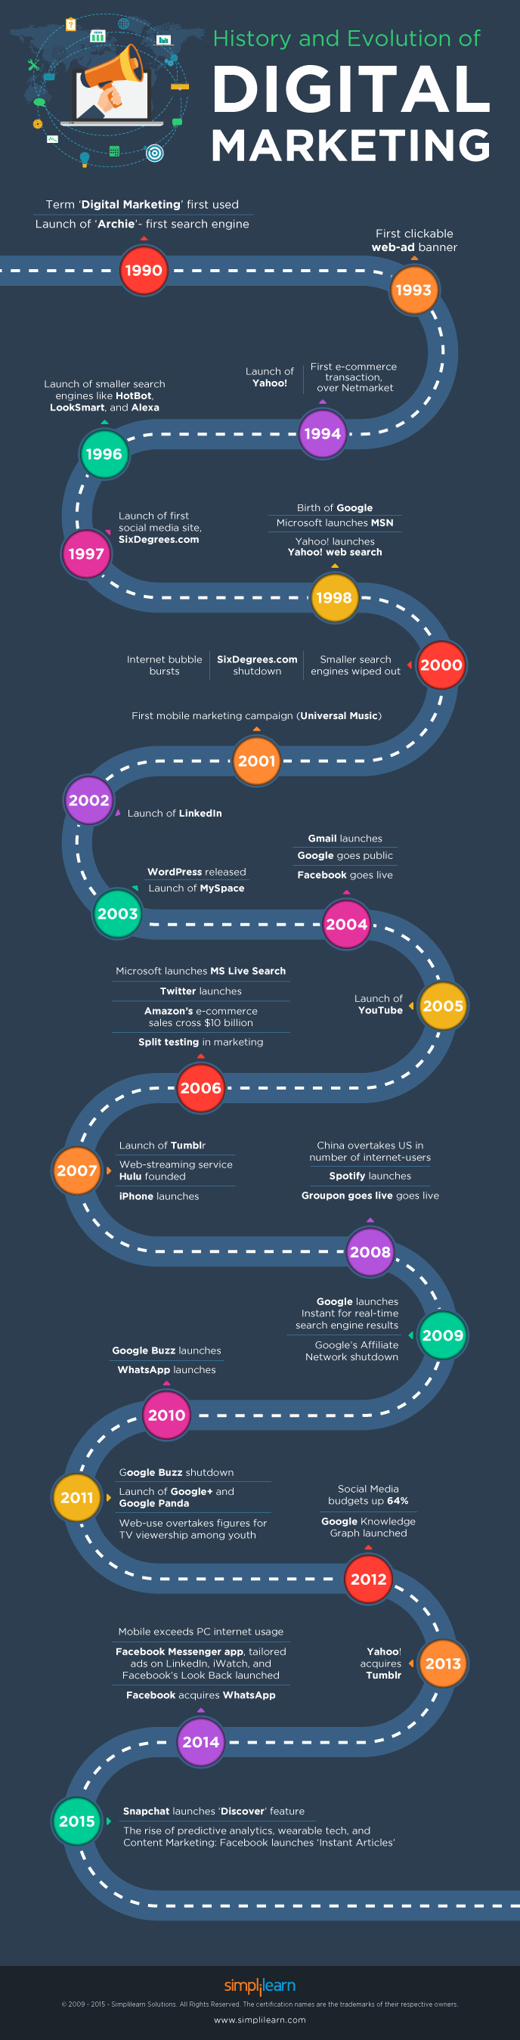

**CHAPTER: 3 OVERVIEW OF THE PROJECT**

In the month of June 2021 we have conducted a survey on TRADITIONAL MARKETING VS DIGITAL MARKETING. By this survey we come to know which marketing is more effective and why it is effective. We created a Google form to conduct the survey and shared through social media applications. By this we got 1003 responses out of 1100 which is equal to 91.18%.

**FREQUENCY**

We have received more responses from female than male for our survey. Precisely we got 52.1% responses from female and 47.9% of responses from male.

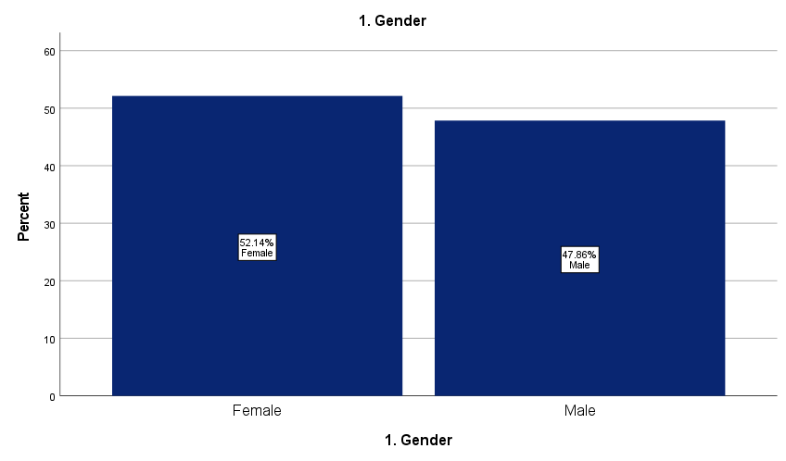

We have received more responses from the age group of 0-20. The least responses we got from the age group of 60-80. precisely we got 37.6% from the age group of 0-20, 35.1% of responses from the age group of 20-40, 19.1% of responses from the age group of 40-60, and 8.2% of responses from the age group of 60-80.

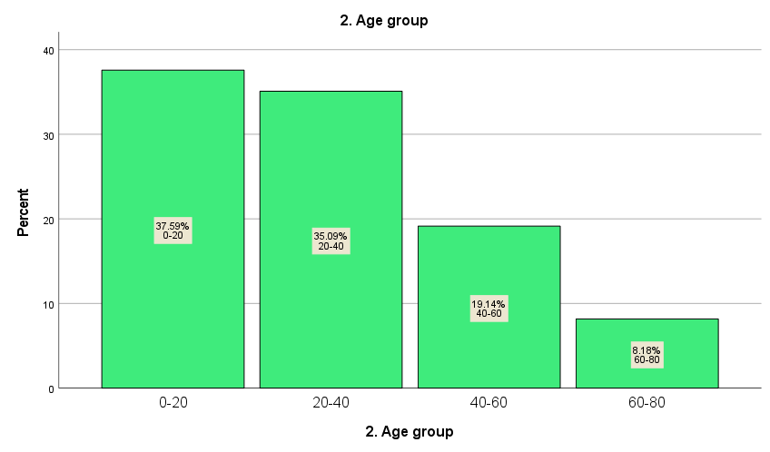

**CHAPTER 4: SUMMARY AND CONCLUSIONS**

* **What method of shopping do you prefer?**

Respondents have given their responses according to their choice. They were having three options first were traditional marketing, second were digital marketing and third were both type of marketing.

**NULL HYPOTHESIS:** All the age group people may have equal opinion on both marketing’s

**ALTERNATIVE HYPOTHESIS:** All the age group people may not have equal opinion on both marketing’s

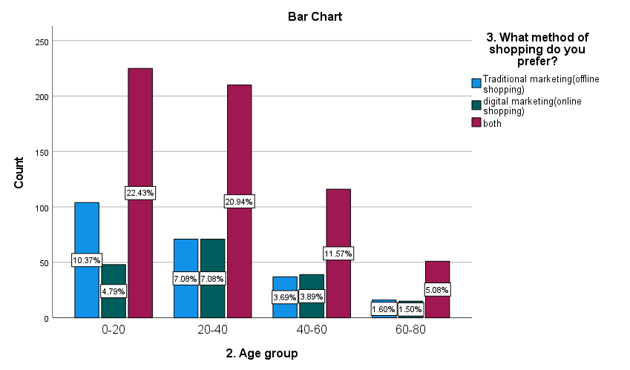

The maximum number of people i.e., 602 prefers both type of marketing. The second least i.e. 228 people like to do traditional marketing and least i.e. 173 people like to do digital marketing.

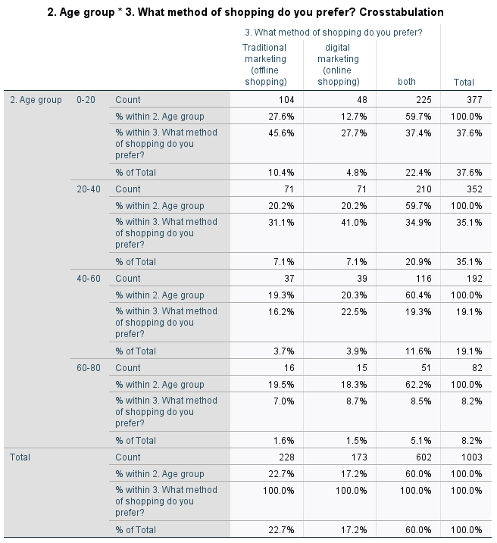

|  |  |  |  |
| --- | --- | --- | --- |
| **Chi-Square Tests** | | | |
|  | Value | Df | Asymptotic Significance (2-sided) |
| Pearson Chi-Square | **13.692a** | **6** | **.033** |
| Likelihood Ratio | **13.855** | **6** | **.031** |
| Linear-by-Linear Association | **2.078** | **1** | **.149** |
| N of Valid Cases | **1003** |  |  |
| a. 0 cells (0.0%) have expected count less than 5. The minimum expected count is 14.14. | | | |

From the above test we can observe that the calculated value is 13.692 with 6df. The p value is 0.033 which is less than the significance level (p<0.05). So we reject null hypothesis i.e. all the age group people may not have equal opinion on both marketing’

* **Have you ever made online shopping?**

From this question we want to know how many respondents have made online shopping. Most of the people made online shopping i.e. we got 632 responses who have made online shopping, 137 people who never made online shopping, 234 people who have made online shopping but for once or twice.

**NULL HYPOTHESIS:**  All the age group people have equal opinions.

**ALTERNATIVE HYPOTHESIS:** All the age group people may not have equal opinions.

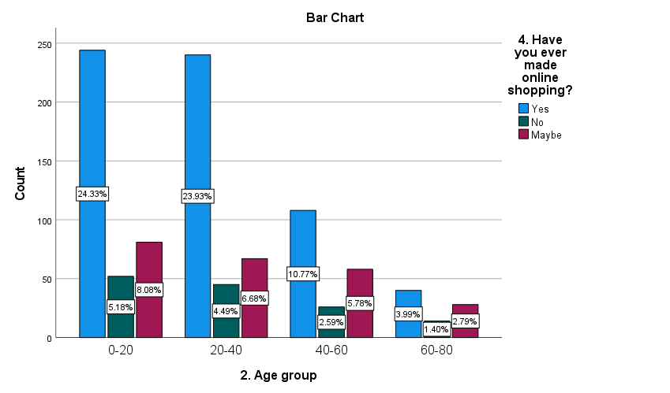

The maximum number of people do online shopping i.e. 63.0% of people like to do online shopping, second least i.e. 23.3% of the people who have done online shopping for once or twice and 13.7% people who never made online shopping

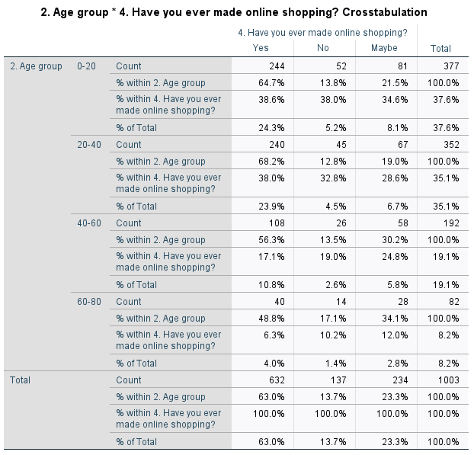

|  |  |  |  |
| --- | --- | --- | --- |
| **Chi-Square Tests** | | | |
|  | Value | Df | Asymptotic Significance (2-sided) |
| Pearson Chi-Square | **17.941a** | **6** | **.006** |
| Likelihood Ratio | **17.479** | **6** | **.008** |
| Linear-by-Linear Association | **10.271** | **1** | **.001** |
| N of Valid Cases | **1003** |  |  |
| a. 0 cells (0.0%) have expected count less than 5. The minimum expected count is 11.20. | | | |

From the above test we can observe that the calculated value is 17.942 for 6df. The p value is 0.006 which is less than the significance value (p<0.05) . we accept alternative hypothesis i.e. All the age group people may not have equal opinions.

* **Have you felt any problem on conducting online purchase?**

Here most of the people had problem in conducting online purchase i.e. 568 people had problems on conducting online purchase and 435 people have never had any problem on conducting online purchase.

**NULL HYPOTHESIS :** All the age group people may have equal problem on conducting online purchase.

**ALTERNATIVE HYPOTHESIS :** All the age group people may not have equal problem on conducting online purchase.

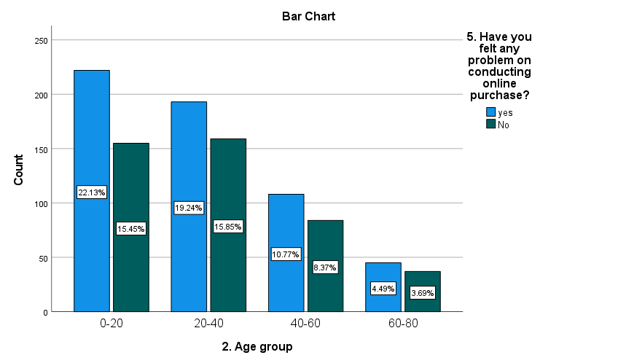

The maximum number of people i.e. 56.6% had problems on conducting online purchase and 43.4% of people didn’t had any problem on conducting online purchase

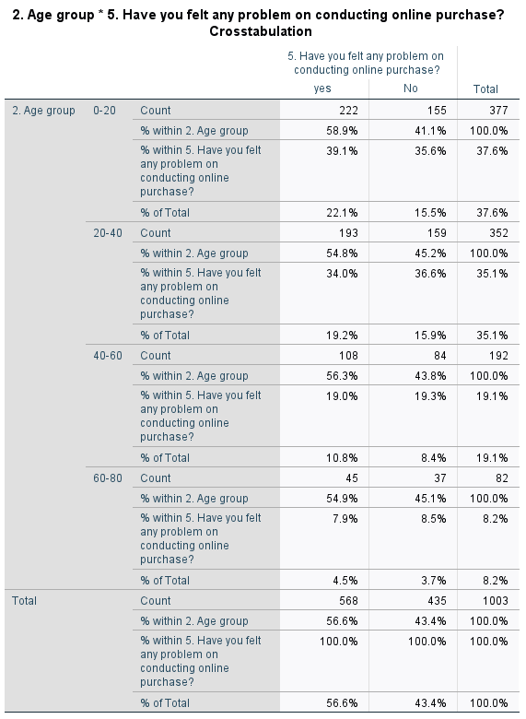

|  |  |  |  |
| --- | --- | --- | --- |
| **Chi-Square Tests** | | | |
|  | **Value** | **Df** | **Asymptotic Significance (2-sided)** |
| Pearson Chi-Square | **1.360a** | **3** | **.715** |
| Likelihood Ratio | **1.361** | **3** | **.715** |
| Linear-by-Linear Association | **.665** | **1** | **.415** |
| N of Valid Cases | **1003** |  |  |
| a. 0 cells (0.0%) have expected count less than 5. The minimum expected count is 35.56. | | | |

By this we can observe that the calculated is 1.360 for 3df. The p value is 0.715 which is less than significance value (p<0.5). Hence we accept alternative hypothesis i.e. All the age group people may not have equal problem on conducting online purchase.

* **If yes, what kind of problem?**

Here from this we want to know what kind of problems they faced during the time of online purchase. Most of the people got cheap quality products.

**NULL HYPOTHESIS :**  All the age group people may have equal problem with all the factors.

**ALTERNATIVE HYPOTHESIS :** All the age group people may not have equal problem with all the factors.

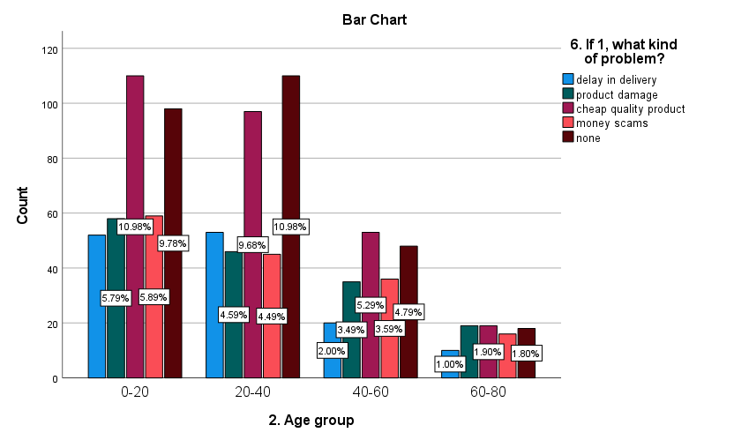

Here most of the people i.e. 279 had problem on conducting online purchase which is they got cheap quality products. 274 people didn’t had any problem, 158 people have got damaged product, 156 people have faced money scams and 135 people got problem as delay in delivery.

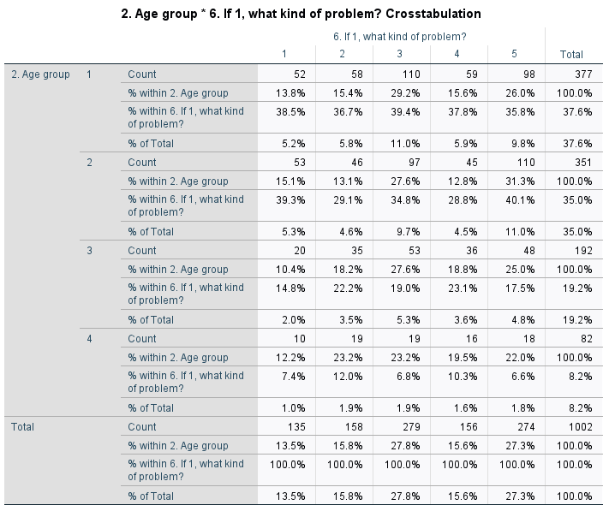

|  |  |  |  |
| --- | --- | --- | --- |
| **Chi-Square Tests** | | | |
|  | **Value** | **Df** | **Asymptotic Significance (2-sided)** |
| Pearson Chi-Square | **15.572a** | **12** | **.212** |
| Likelihood Ratio | **15.354** | **12** | **.223** |
| Linear-by-Linear Association | **.011** | **1** | **.918** |
| N of Valid Cases | **1002** |  |  |
| **a. 0 cells (0.0%) have expected count less than 5. The minimum expected count is 11.05.** | | | |

From this we can observe that the calculated value is 15.572. The p value is 0.212 for 12df which is less than the significance value (0.05). Hence we accept alternative hypothesis i.e., All the age group people may not have equal problem with all the factors.

* **Reason for choosing online shopping?**

Here by this we want to know that most of the people why they prefer online shopping. Most of the people prefer online shopping for saving their time

**NULL HYPOTHESIS :** All the age group may have equal reasons.

**ALTERNATIVE HYPOTHESIS :** All the age group may not have equal reasons.

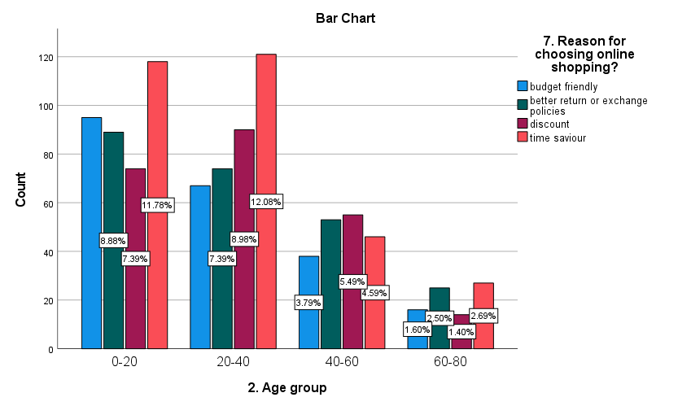

Here we get to know that most of the people i.e. 312 do online shopping for saving their time. The least response i.e. 216 like to do online shopping because it is budget friendly

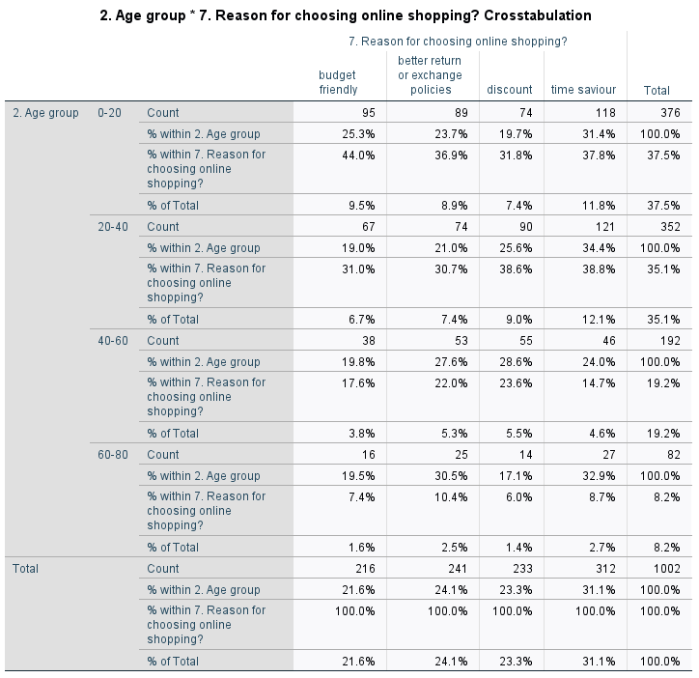

|  |  |  |  |
| --- | --- | --- | --- |
| **Chi square** | | | |
|  | Value | df | Asymptotic Significance (2-sided) |
| Pearson Chi-Square | **18.738a** | **9** | **.028** |
| Likelihood Ratio | **18.867** | **9** | **.026** |
| Linear-by-Linear Association | **.101** | **1** | **.750** |
| N of Valid Cases | **1002** |  |  |
| a. 0 cells (0.0%) have expected count less than 5. The minimum expected count is 17.68. | | | |

From this test we can observe that the calculated value is 18.738. The p value is 0.028 for 9df which is less than the significance value (p<0.5). Hence we accept alternative hypothesis i.e. All the age group may not have equal reasons.

* **Reason for choosing offline shopping?**

From this we want to know why people like to do offline shopping. We got 414 responses for which the reason is to check the quality. Least response i.e., 166 because the reason is budget friendly.

**NULL HYPOTHESIS :** All the age group people may have equal opinions.

**ALTERNATIVE HYPOTHESIS :** All the age group people may not have equal opinions.

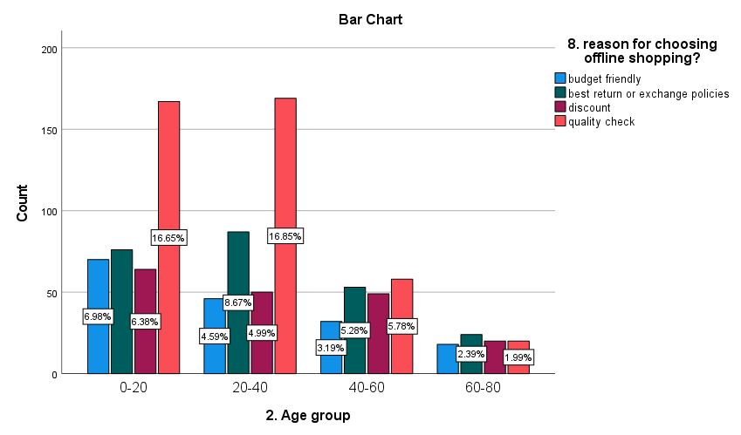

Here we can observe that most of the people i.e. 414 like to do offline shopping to check the quality of the product. 240 people like to do shopping for better return or exchange policies. 183 people like to do offline shopping for discount and 166 people like to do offline shopping for budget friendly products.

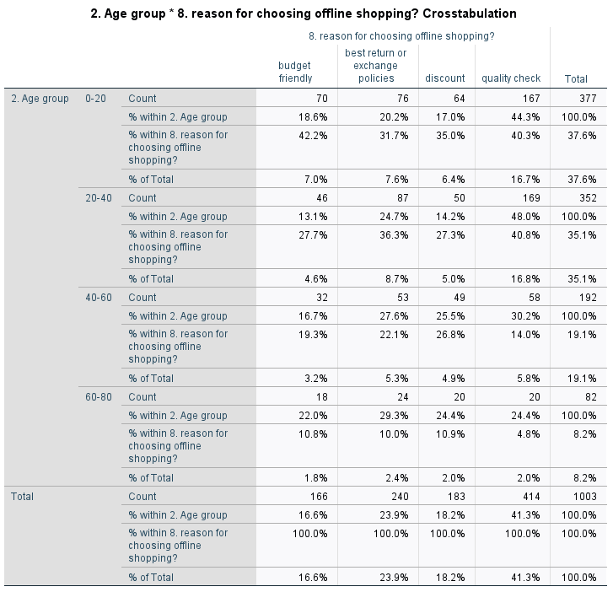

|  |  |  |  |
| --- | --- | --- | --- |
| **Chi-Square Tests** | | | |
|  | Value | df | Asymptotic Significance (2-sided) |
| Pearson Chi-Square | **36.159a** | **9** | **<.001** |
| Likelihood Ratio | **37.046** | **9** | **<.001** |
| Linear-by-Linear Association | **7.525** | **1** | **.006** |
| N of Valid Cases | **1003** |  |  |
| a. 0 cells (0.0%) have expected count less than 5. The minimum expected count is 13.57. | | | |

From this we can observe that the calculated value is 36.159 for 9df. The p value is 0.001 which is less than the significance value (p<0.5). Hence we accept alternative hypothesis i.e. All the age group people may not have same reason for choosing offline shopping.

* **Choose the product you prefer in online shopping?**

From this we want to know what type of products they choose in online shopping. Most of the people prefer clothing and foot wear for online shopping.

**NULL HYPOTHESIS :** All the age group people may choose same product in doing online shopping.

**ALTERNATIVE HYPOTHESIS :** All the age group people may not choose same product in doing online shopping.

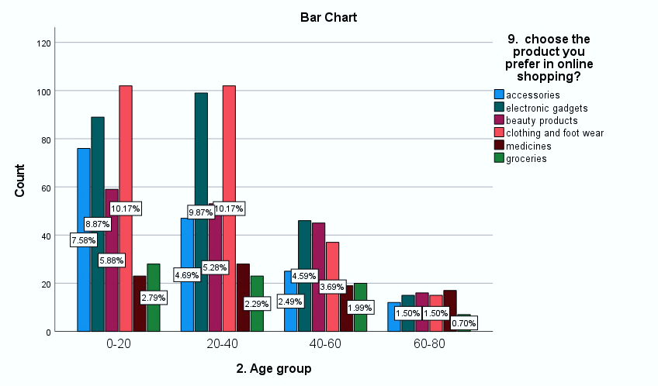

Here we cam observe that most of the i.e. 256 prefer clothing and footwear in online shopping, 249 people prefer electronic gadgets, 173 people prefer beauty products, 160 people prefer accessories, 87 prefer medicines and 78 prefer groceries. All the age group people may not choose same product in doing online shopping.

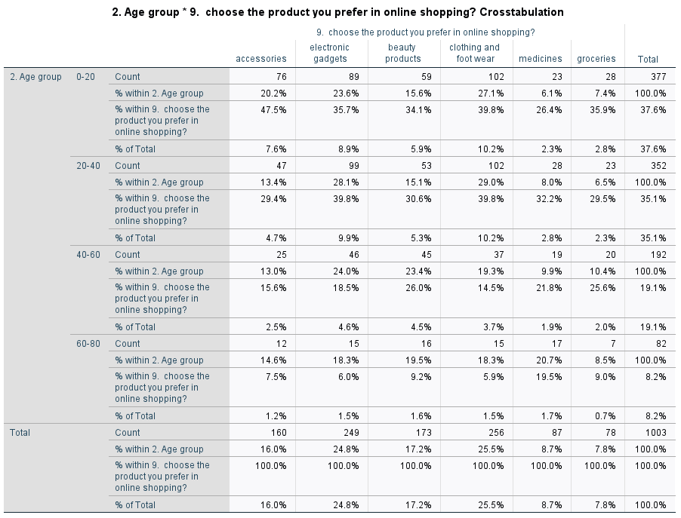

|  |  |  |  |
| --- | --- | --- | --- |
| **Chi-Square Tests** | | | |
|  | Value | df | Asymptotic Significance (2-sided) |
| Pearson Chi-Square | **42.396a** | **15** | **<.001** |
| Likelihood Ratio | **38.623** | **15** | **<.001** |
| Linear-by-Linear Association | **6.412** | **1** | **.011** |
| N of Valid Cases | **1003** |  |  |
| a. 0 cells (0.0%) have expected count less than 5. The minimum expected count is 6.38. | | | |

From this test we can observe that the calculated value is 42.396 for 15df. The p value is 0.001 which is less than the significance value (p<0.5). Hence we accept alternative hypothesis i.e. All the age group people may not choose same product in doing online shopping.

* **Choose the product you prefer in offline shopping.**

Here most of the people prefer to choose clothing and footwear i.e. 287 respondents want to choose clothing and foot wear. Least people i.e. 92 people choose groceries in offline shopping.

**NULL HYPOTHESIS :** All the age group people may choose same product.

**ALTERNATIVE HYPOTHESIS :** All the age group people may not choose same product.

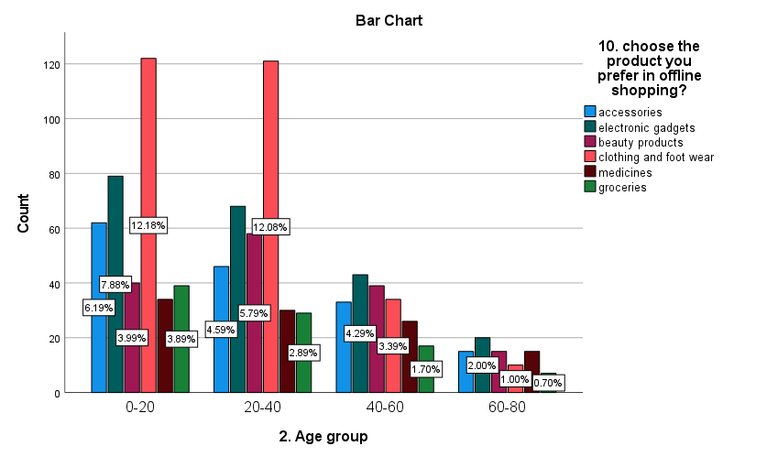

here we can observe that 28.6% choose clothing and foot wear in offline shopping, 21.0% choose electronic gadgets in offline shopping, 15.6% choose accessories, 15.2% of people choose beauty products, 10.5% people choose medicines, and 9.2% of people choose groceries in offline shopping.

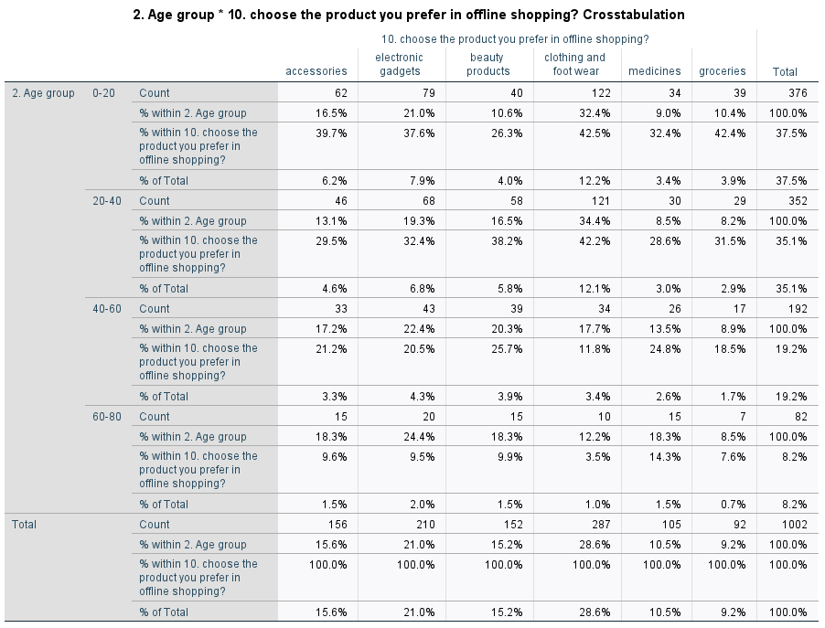

|  |  |  |  |
| --- | --- | --- | --- |
| **Chi-Square Tests** | | | |
|  | Value | df | Asymptotic Significance (2-sided) |
| Pearson Chi-Square | **43.996a** | **15** | **<.001** |
| Likelihood Ratio | **46.451** | **15** | **<.001** |
| Linear-by-Linear Association | **1.163** | **1** | **.281** |
| N of Valid Cases | **1002** |  |  |
| a. 0 cells (0.0%) have expected count less than 5. The minimum expected count is 7.53. | | | |

From this we can observe that the calculated value is 43.996 for 15df . The p value is 0.001 which is less than the significance value (p<0.5). Hence we accept alternative hypothesis i.e. All the age group people may not choose same product.

* **Do you have any concerns about your data privacy while doing online shopping?**

Here we want to know that whether how many of their data is secured while doing online shopping.

**NULL HYPOTHESIS :** All the people may have concern about their data privacy

**ALTERNATIVE HYPOTHESIS :** All the people may not have concern about their data privacy.

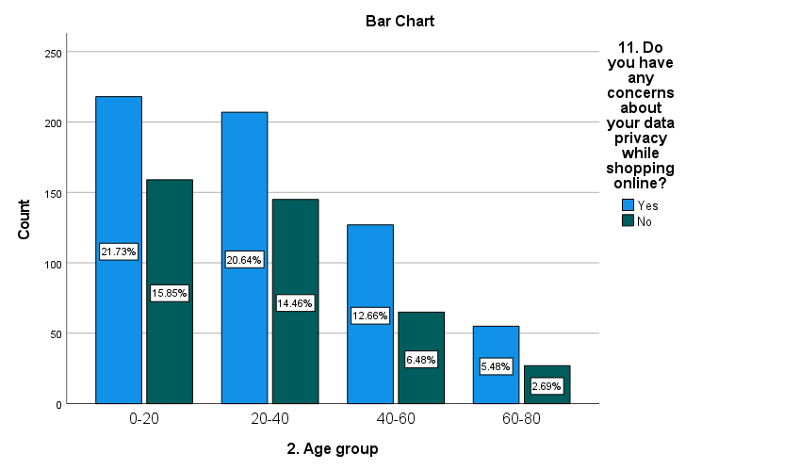

Here most of the people i.e. 60.5% have concerns about their data whenever they purchase online, and 39.5% of the people don’t have any concern.

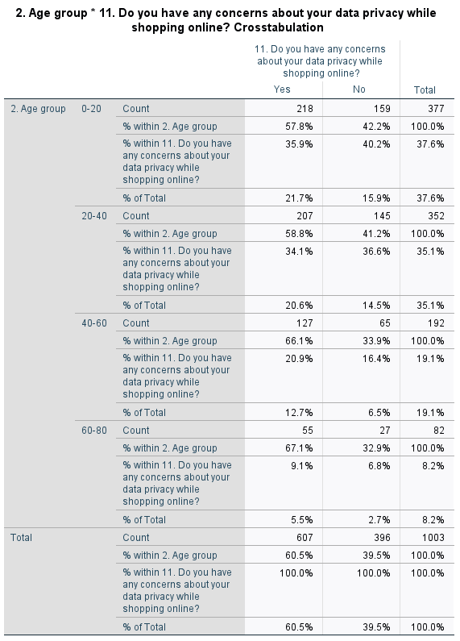

|  |  |  |  |
| --- | --- | --- | --- |
| **Chi-Square Tests** | | | |
|  | Value | df | Asymptotic Significance (2-sided) |
| Pearson Chi-Square | **5.595a** | **3** | **.133** |
| Likelihood Ratio | **5.668** | **3** | **.129** |
| Linear-by-Linear Association | **4.689** | **1** | **.030** |
| N of Valid Cases | **1003** |  |  |
| a. 0 cells (0.0%) have expected count less than 5. The minimum expected count is 32.37. | | | |

From this we can observe that the calculated value is 5.959 for 3df. the p value is 0.133 which is less than significance value. Hence we accept alternative hypothesis i.e. All the people may not have concern about their data privacy.

* **What is your satisfaction level while doing online shopping?**

Here from this we want to know whether they are satisfied while doing online shopping. Most of the people are satisfied with their online shopping.

**NULL HYPOTHESIS :** All the people may have equal satisfaction level.

**ALTERNATIVE HYPOTHESIS :** All the people may not have equal satisfaction level.

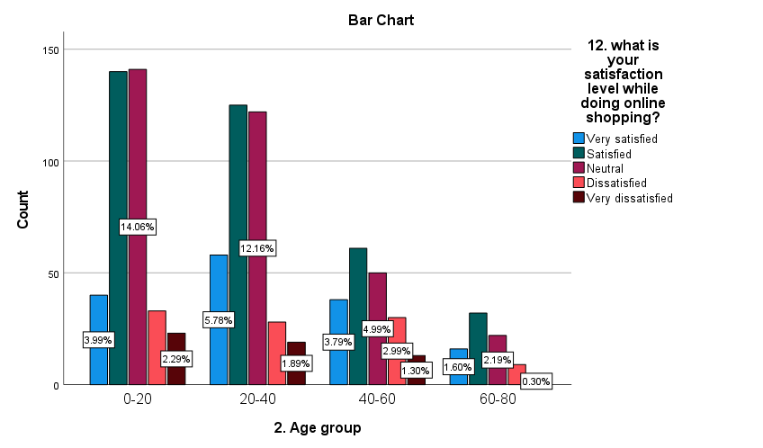

from the above table we can observe that most of the people i.e. 35.7% are satisfied while doing online shopping, 33.4% are neutral, 15.2% of people are very satisfied, 10% of the people are dissatisfied and 5.8% people are very dissatisfied with their online shopping

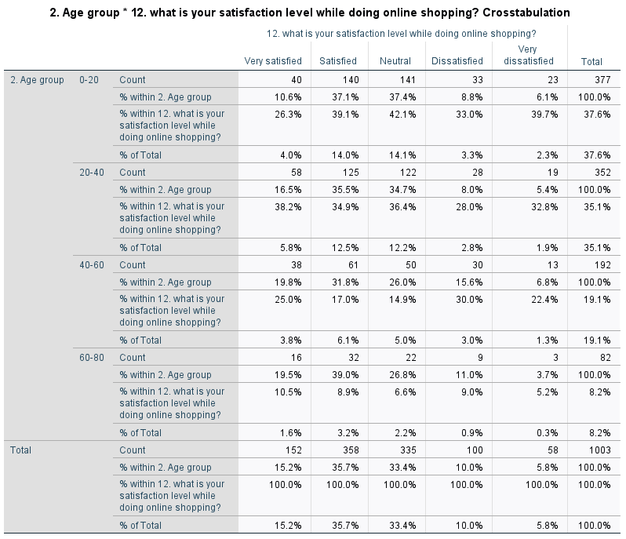

|  |  |  |  |
| --- | --- | --- | --- |
| **Chi-Square Tests** | | | |
|  | Value | df | Asymptotic Significance (2-sided) |
| Pearson Chi-Square | **26.103a** | **12** | **.010** |
| Likelihood Ratio | **25.952** | **12** | **.011** |
| Linear-by-Linear Association | **2.277** | **1** | **.131** |
| N of Valid Cases | **1003** |  |  |
| a. 1 cells (5.0%) have expected count less than 5. The minimum expected count is 4.74. | | | |

From the above table we can observe that the calculated value is 26.103 for 12df. the p value is 0.010 which is less than the significance value. Hence we accept alternative hypothesis, i.e.All the people may not have equal satisfaction level.

* **What is your satisfaction level while doing offline shopping?**

From the above question we want to know that how much they are satisfied with their offline shopping.

**NULL HYPOTHESIS :** All the people may have equal satisfaction level.

**ALTERNATIVE HYPOTHESIS :** All the people may not have equal satisfaction level.

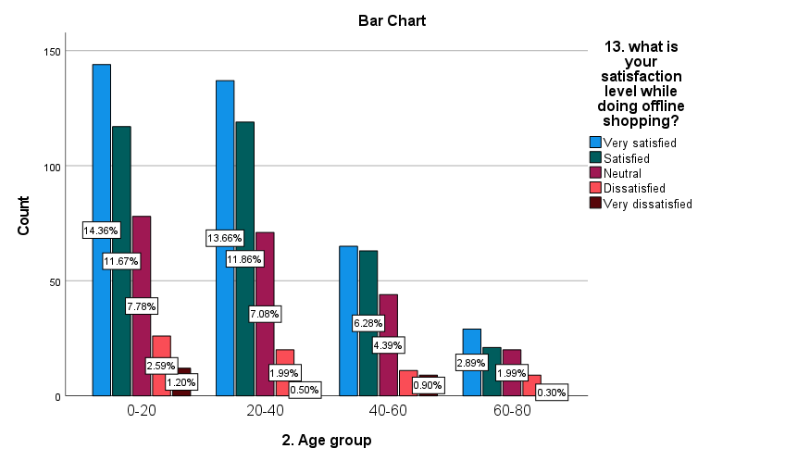

Here from this table we can observe that 37.4% of the people are very satisfied with their offline shopping, 31.9% are satisfied, 21.2% are neutral, 6,6% are dissatisfied, and 2.9% are very dissatisfied

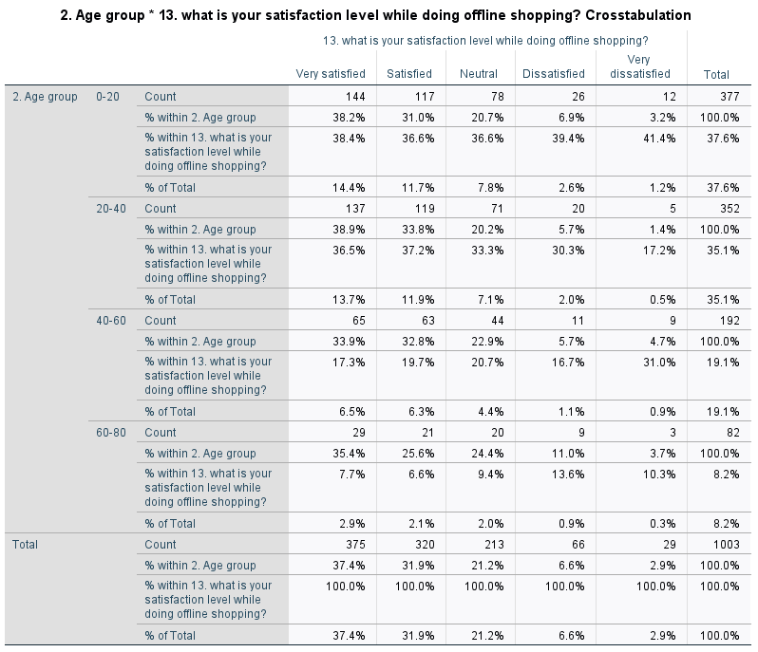

|  |  |  |  |
| --- | --- | --- | --- |
| **Chi-Square Tests** | | | |
|  | Value | df | Asymptotic Significance (2-sided) |
| Pearson Chi-Square | 11.618a | 12 | .477 |
| Likelihood Ratio | 11.561 | 12 | .482 |
| Linear-by-Linear Association | 1.879 | 1 | .170 |
| N of Valid Cases | 1003 |  |  |
| a. 1 cells (5.0%) have expected count less than 5. The minimum expected count is 2.37. | | | |

From the above table we can observe that the calculated value is 11.618 for 12df. The p value is 0.477 which is less than significance value. Hence we accept alternative hypothesis i.e. All the people may not have equal satisfaction level.

* **Which of the following is the most important factor to buy a product in online shopping?**

Here we will get to know that what is the main factor for which they decide to do shopping in online for a particular product.

**NULL HYPOTHESIS :** All age group people may have equal factors.

**ALTERNATIVE HYPOTHESIS :** All age group people may not have equal factors.

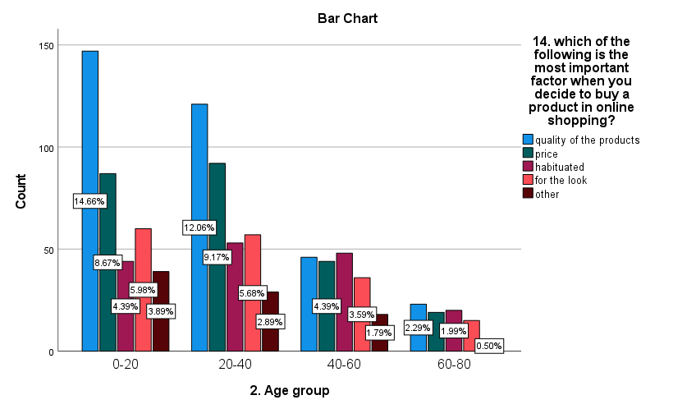

Here from this table we can observe that most of the people i.e. 33.6% have important factor as quality of the product while doing online shopping, 24.1% of the people have important factor as price while doing online shopping, 16.7% of the people have important as for the look, 16.5% of the people have important factor as habituated and 9.1% people have their other opinions.

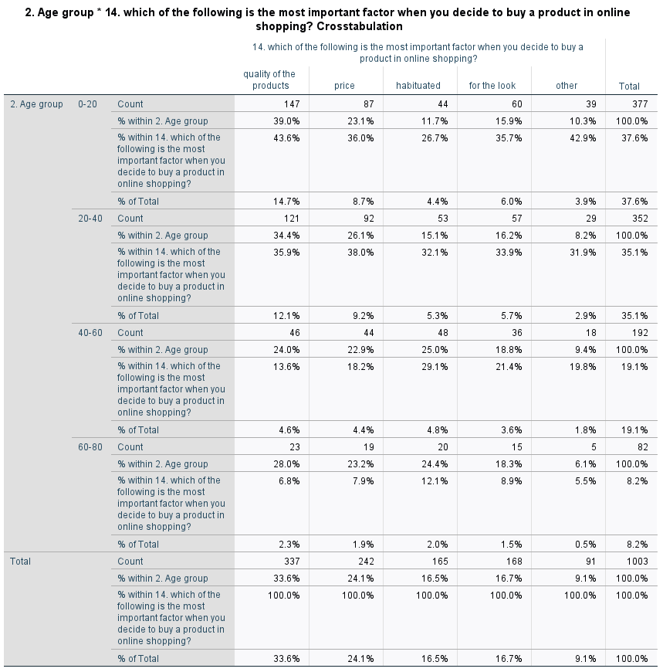

|  |  |  |  |
| --- | --- | --- | --- |
| **Chi-Square Tests** | | | |
|  | Value | df | Asymptotic Significance (2-sided) |
| Pearson Chi-Square | **30.181a** | **12** | **.003** |
| Likelihood Ratio | **29.732** | **12** | **.003** |
| Linear-by-Linear Association | **4.709** | **1** | **.030** |
| N of Valid Cases | **1003** |  |  |
| a. 0 cells (0.0%) have expected count less than 5. The minimum expected count is 7.44. | | | |

From the above table we can observe that the calculated value is 30.181 for 12df. The p value is 0.003 which is less than significance value. Hence we accept alternative hypothesis, i.e. All age group people may not have equal factors.

* **Which of the following is the most important factor while doing offline shopping?**

Here we can know that the factors for which most of the people like to do offline shopping.

**NULL HYPOTHESIS :** All age group people may have equal factors.

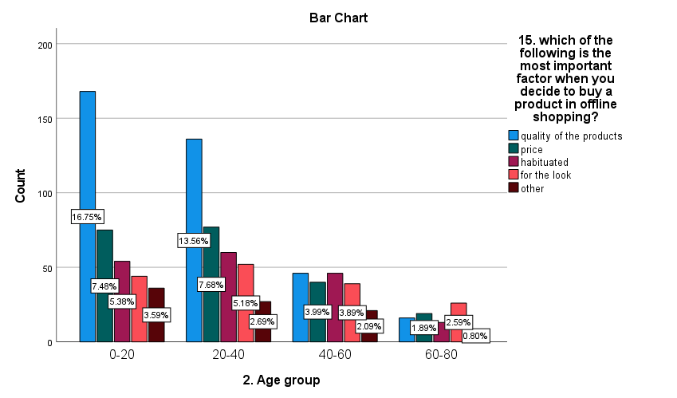**ALTERNATIVE HYPOTHESIS :** All age group people may not have equal factors.

Here from this table we can observe that 36.5% people have important factor as quality of the product while choosing a product in offline shopping, 21.0% people have important factor as price , 17.2% of the people have important factor as habituated, 16.1% people have important factor as for the look, and 9.2% have their other opinions.

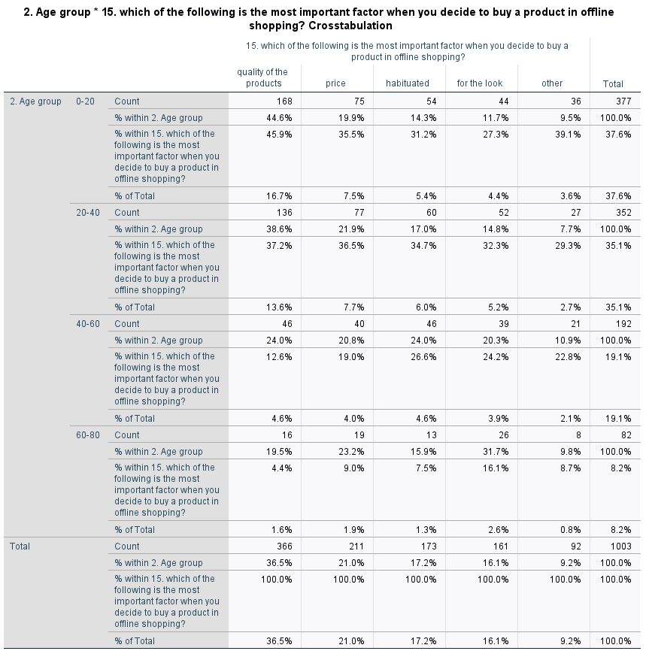

|  |  |  |  |
| --- | --- | --- | --- |
| **Chi-Square Tests** | | | |
|  | Value | df | Asymptotic Significance (2-sided) |
| Pearson Chi-Square | **50.597a** | **12** | **<.001** |
| Likelihood Ratio | **49.727** | **12** | **<.001** |
| Linear-by-Linear Association | **27.569** | **1** | **<.001** |
| N of Valid Cases | **1003** |  |  |
| a. 0 cells (0.0%) have expected count less than 5. The minimum expected count is 7.52. | | | |

From the above table we can observe that the calculated value is 50.597 for 12df. The p value is 0.001 which is less than the significance value. Hence we accept alternative hypothesis, All age group people may not have equal factors.

* **What type of products are you more likely to buy in online shopping?**

Here we want to know that what type what they look in their products when they buy online. Most of the people look for branded products when they buy online.

**NULL HYPOTHESIS :** All the age group people may have equal thoughts.

**ALTERNATIVE HYPOTHESIS :** All the age group people may not have equal thoughts.

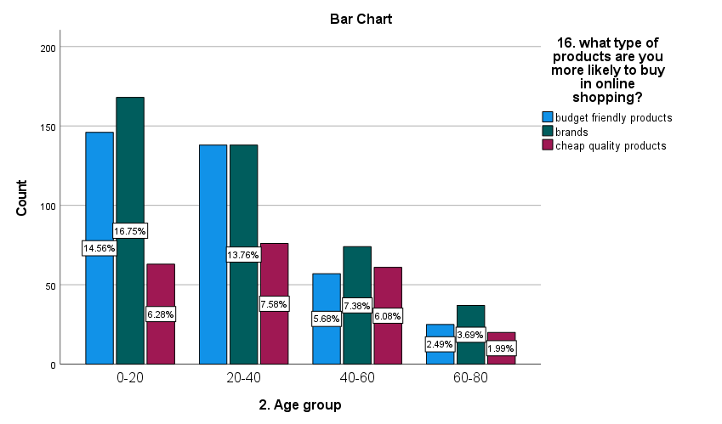

Here from the above table we can observe that most of the people i.e. 41.6% of them look for branded products, 36.5% of people look for budget friendly products, and 21.9% of the people look for cheap products.

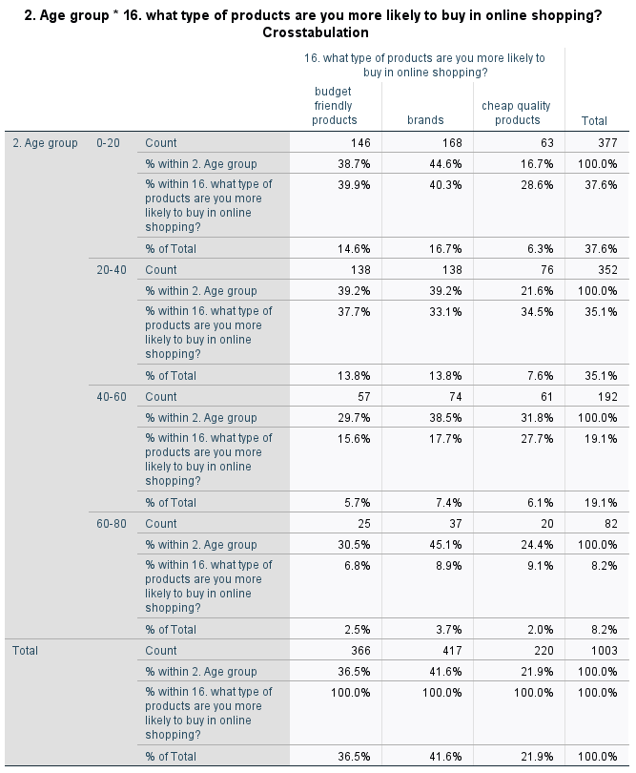

|  |  |  |  |
| --- | --- | --- | --- |
| **Chi-Square Tests** | | | |
|  | Value | df | Asymptotic Significance (2-sided) |
| Pearson Chi-Square | **19.834a** | **6** | **.003** |
| Likelihood Ratio | **19.392** | **6** | **.004** |
| N of Valid Cases | **1003** |  |  |
| a. 0 cells (0.0%) have expected count less than 5. The minimum expected count is 17.99. | | | |

From the above table we can observe that the calculated value is 19.834 for 6df. The p value is 0.003 which is less than the significance value. Hence we accept alternative hypothesis, i.e. All the age group people may not have equal thoughts

* **What type of products are you more likely to buy in offline shopping.**

Here we want to know that what type what they look in their products when they buy offline. Most of the people look for budget friendly products when they buy offline.

**NULL HYPOTHESIS :** All the age group people may have equal thoughts.

**ALTERNATIVE HYPOTHESIS :** All the age group people may not have equal thoughts.

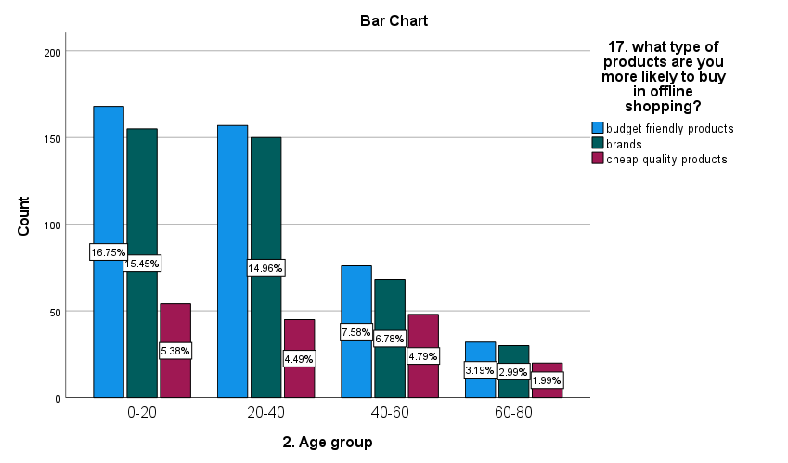

Here from this table we can observe that most of the people i.e. 43.2% of them like to buy budget friendly products in offline shopping, 40/2% of the people like to buy branded products, and 16.7% of the people like to buy cheap quality products.

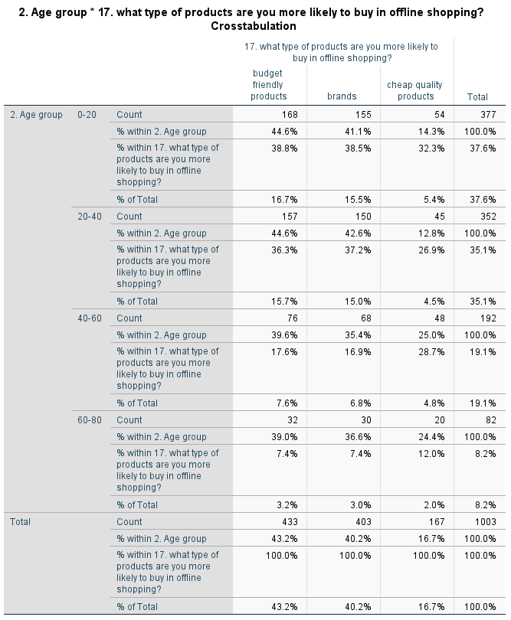

|  |  |  |  |
| --- | --- | --- | --- |
| **Chi-Square Tests** | | | |
|  | Value | df | Asymptotic Significance (2-sided) |
| Pearson Chi-Square | **18.559a** | **6** | **.005** |
| Likelihood Ratio | **17.508** | **6** | **.008** |
| N of Valid Cases | **1003** |  |  |
| a. 0 cells (0.0%) have expected count less than 5. The minimum expected count is 13.65. | | | |

Here from the above table we can observe that the calculated value is 18.559 for 6df. The p value is 0.005 which is less than the significance value. Hence we accept alternative hypothesis, i.e. All the age group people may not have equal thoughts.

* **Digital marketing has far more freedom of choice than a traditional marketing.**

Here we gave a statement which says that in digital marketing we have more choice and we don’t have that much of choice in traditional marketing. For this statement most of the response we got for neutral and then the least response we got for strongly disagree.

**NULL HYPOTHESIS :**  All the age group people may have equal opinions.

**ALTERNATIVE HYPOTHESIS :** All the age group people may not have equal opinions.

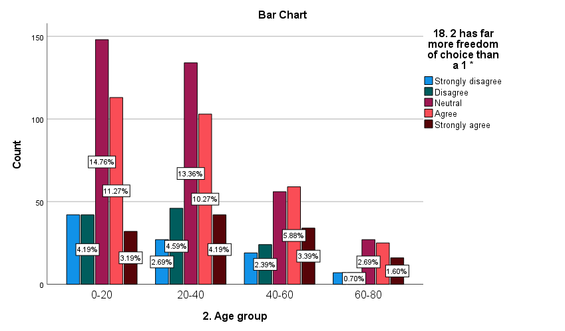

Here from the above table we can observe that most of the people give response for the option neutral, 29.9% of the people agree with the statement, 12.4% of the people strongly agree with the statement, 11.9% of the people disagree with the statement, and 9.5% of the people strongly disagree with the statement.

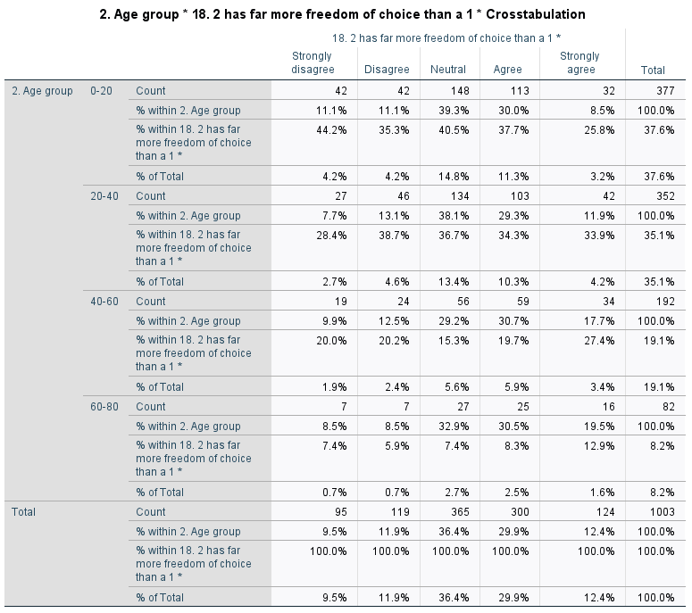

|  |  |  |  |
| --- | --- | --- | --- |
| **Chi-Square Tests** | | | |
|  | **Value** | **df** | **Asymptotic Significance (2-sided)** |
| Pearson Chi-Square | **20.562a** | **12** | **.057** |
| Likelihood Ratio | **20.378** | **12** | **.060** |
| Linear-by-Linear Association | **7.476** | **1** | **.006** |
| N of Valid Cases | **1003** |  |  |
| a. 0 cells (0.0%) have expected count less than 5. The minimum expected count is 7.77. | | | |

Here from the above test we can observe that the calculated value is 20.562 for 12df. The p value is 0.057 which is less than the significance value. Hence we accept alternative hypothesis, i.e. All the age group people may not have equal opinions.

* **Branding ads through social media has more reach than television.**

Here from this question we want to know how many will agree with this statement. In this we say that social media has more effect than television. Now a day’s most of the people use social media for advertisement.

**NULL HYPOTHESIS :** All the age group people may agree

**ALTERNATIVE HYPOTHESIS :** All the age group people may not agree .

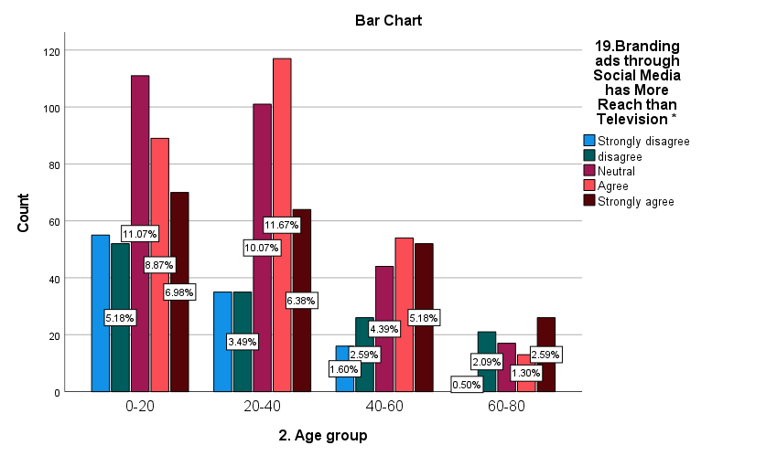

Here from the above table we can observe that most of the people i.e. 27.2% agree with the statement, 27.2% give the response as neutral, 21.1% of the people strongly agre

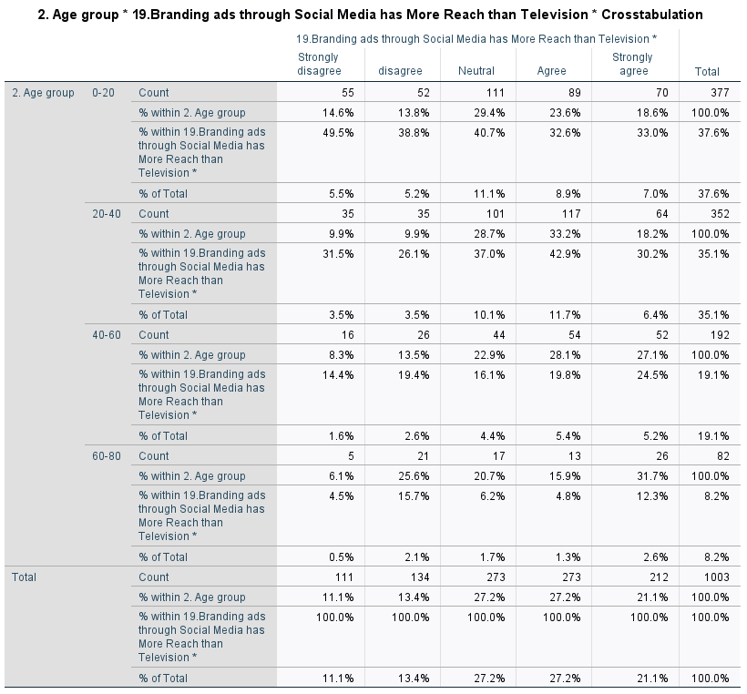

|  |  |  |  |
| --- | --- | --- | --- |
| **Chi-Square Tests** | | | |
|  | Value | df | Asymptotic Significance (2-sided) |
| Pearson Chi-Square | **44.258a** | **12** | **<.001** |
| Likelihood Ratio | **42.607** | **12** | **<.001** |
| Linear-by-Linear Association | **8.256** | **1** | **.004** |
| N of Valid Cases | **1003** |  |  |
| a. 0 cells (0.0%) have expected count less than 5. The minimum expected count is 9.07. | | | |

Here from the above test we can observe that the calculated value is 44.258 for 12df. The p value is 0.001 which is less than the significance value. Hence we accept alternative hypothesis, i.e. All the age group people may not agree .

* **Which marketing helped you in this pandemic situation?**

In this pandemic digital marketing helped people to buying their products by sitting at home.

**NULL HYPOTHESIS :** All the age group people may have equal opinions.

**ALTERNATIVE HYPOTHESIS :** All the age group people may not have equal opinions.

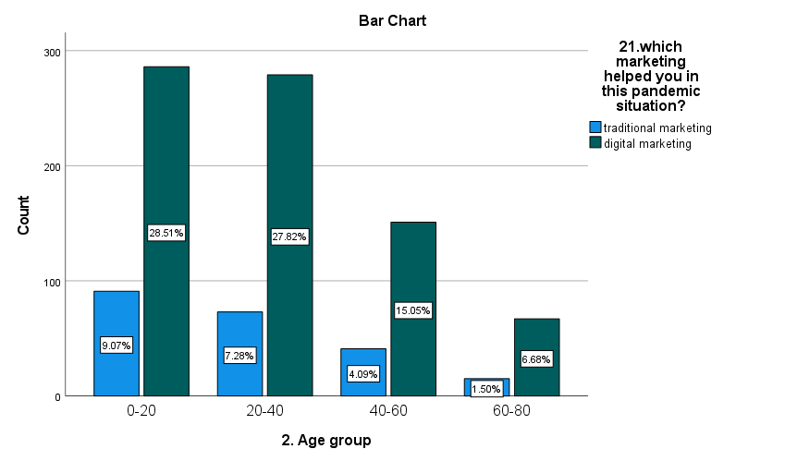

Here from the above table we can observe that 78.3% of the people says that in this pandemic situation digital marketing helped them and 21.9% of the people say that traditional marketing helped them.

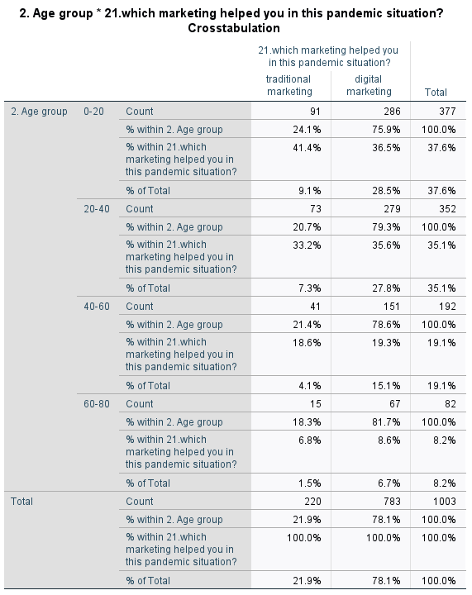

|  |  |  |  |
| --- | --- | --- | --- |
| **Chi square** | | | |
|  | **Value** | **df** | **Asymptotic Significance (2-sided)** |
| Pearson Chi-Square | **2.036a** | **3** | **.565** |
| Likelihood Ratio | **2.043** | **3** | **.563** |
| Linear-by-Linear Association | **1.542** | **1** | **.214** |
| N of Valid Cases | **1003** |  |  |
| **a. 0 cells (0.0%) have expected count less than 5. The minimum expected count is 17.99.** | | | |

Here from the above test we can observe that the calculated value is 2.036 for 3df. The p value is 0.565 which is less than the significance value. Hence we accept alternative hypothesis i.e. All the age group people may not have equal opinion.

* **For which shopping criteria you always like to do online payment**?

Almost of the people like to do online payment for digital marketing.

**NULL HYPOTHESIS :** All the age group people may use online payment

**ALTERNATIVE HYPOTHESIS :** All the age group people may not use online payment

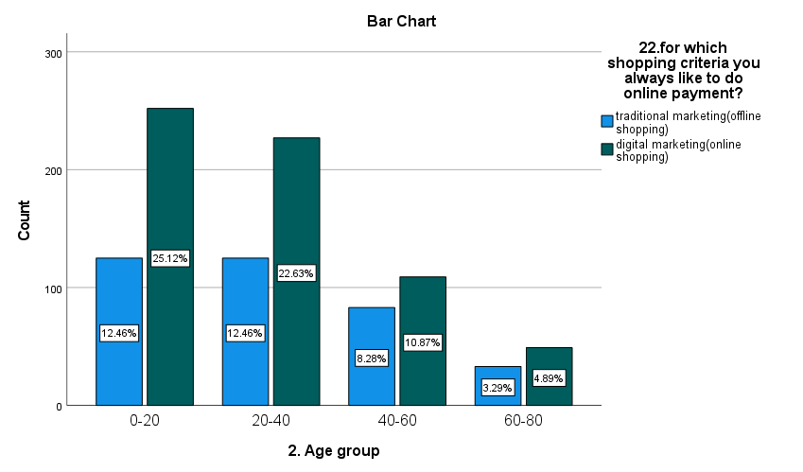

Here from the above table we get to know that most of the people i.e. 63.5% use online payment for digital marketing and 36.5% of the people use online payment for traditional marketing.

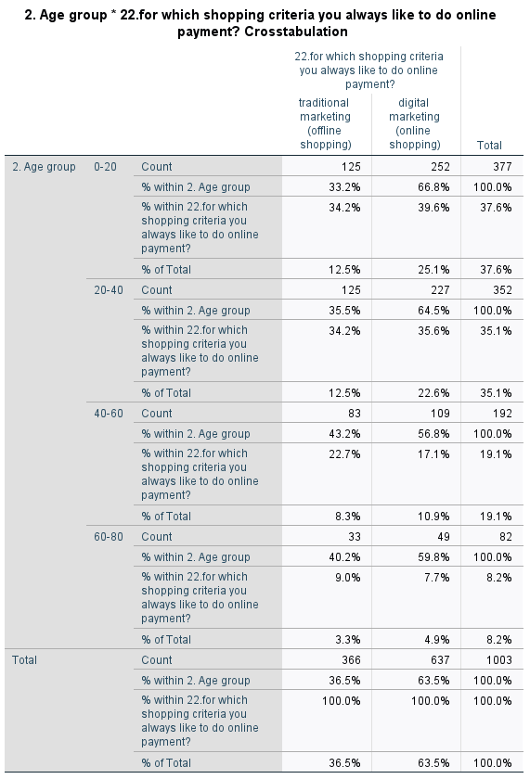

|  |  |  |  |
| --- | --- | --- | --- |
| **Chi-Square Tests** | | | |
|  | Value | df | Asymptotic Significance (2-sided) |
| Pearson Chi-Square | **6.214a** | **3** | **.102** |
| Likelihood Ratio | **6.150** | **3** | **.105** |
| Linear-by-Linear Association | **4.820** | **1** | **.028** |
| N of Valid Cases | **1003** |  |  |
| a. 0 cells (0.0%) have expected count less than 5. The minimum expected count is 29.92. | | | |

Here from the above test we can observe that the calculated value is 6.214 for 3df. The p value is 0.102 less than the significance value. Hence we accept alternative hypothesis i.e. All the age group people may not use online payment.

* **Online payment is not safe for shopping.**

Here from the above question we will get to know that whether online payment is safe or not. Most of the people agree with the statement.

**NULL HYPOTHESIS :** All the age group people may have equal opinions.

**ALTERNATIVE HYPOTHESIS :** All the age group people may not have equal opinions.

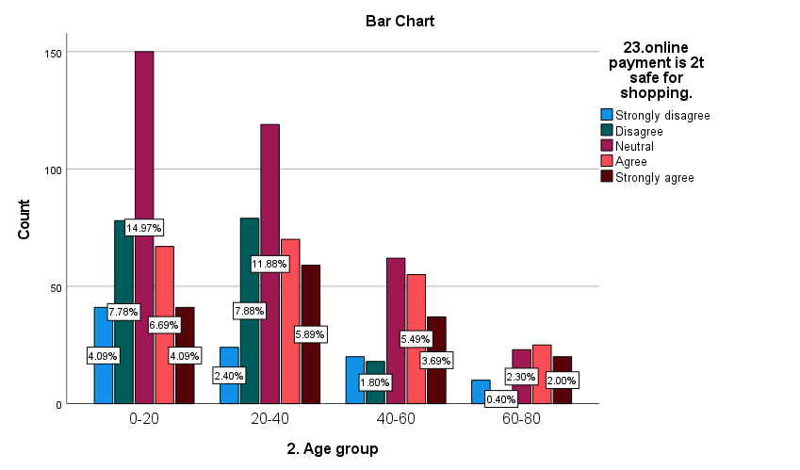

Here we can observe that most of the people give their opinion as neutral on paying online is not safe, 21.7% people agree with statement, 17.9% of the people disagree, 15.7% of the people strongly agree and 9.5% of the people strongly disagree with the statement.

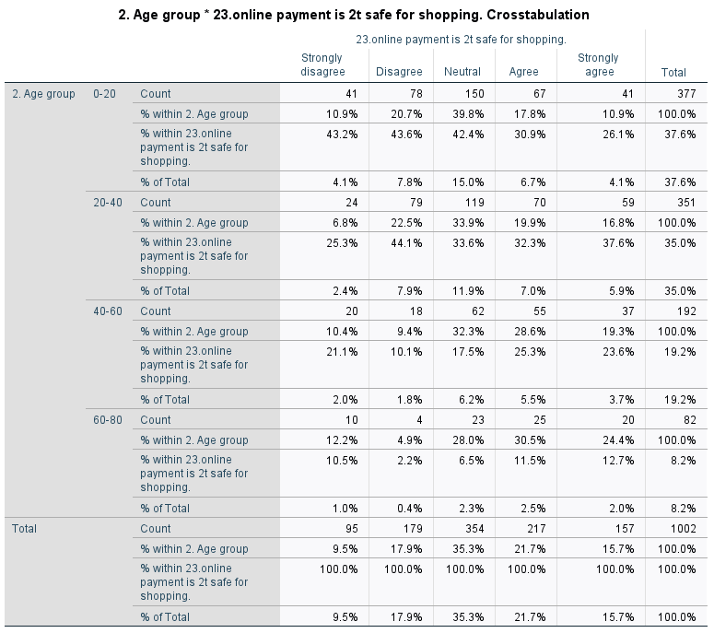

|  |  |  |  |
| --- | --- | --- | --- |
| **Chi-Square Tests** | | | |
|  | **Value** | **df** | **Asymptotic Significance (2-sided)** |
| Pearson Chi-Square | **51.413a** | **12** | **<.001** |
| Likelihood Ratio | **55.452** | **12** | **<.001** |
| Linear-by-Linear Association | **22.707** | **1** | **<.001** |
| N of Valid Cases | **1002** |  |  |
| a. 0 cells (0.0%) have expected count less than 5. The minimum expected count is 7.77. | | | |

Here from the above test we can observe that the calculated value is 51.413 for 12df. The p value is 0.001 which is less than the significance value. Hence we accept alternative hypothesis, i.e. All the age group people may not have equal opinions.

* **Online shopping never guarantee about product.**

Here from the above question we will get to know that whether all agree with this statement or not.

**NULL HYPOTHESIS:** All the age group people may have equal opinions.

**ALTERNATIVE HYPOTHESIS:** All the age group people may not have equal opinions.

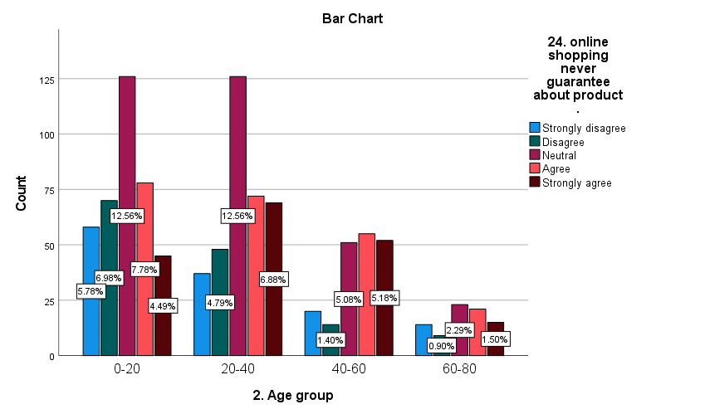

Here from the above table we can observe that most of the people i.e. 32.5% of the people choose the option neutral for the statement “online shopping never guarantee about product”, 22.5% of the people agree with the statement, 18.0% of the people strongly agree with the statement, 14.1% of the people disagree with the statement, 12.9% of the people strongly disagree with the statement.

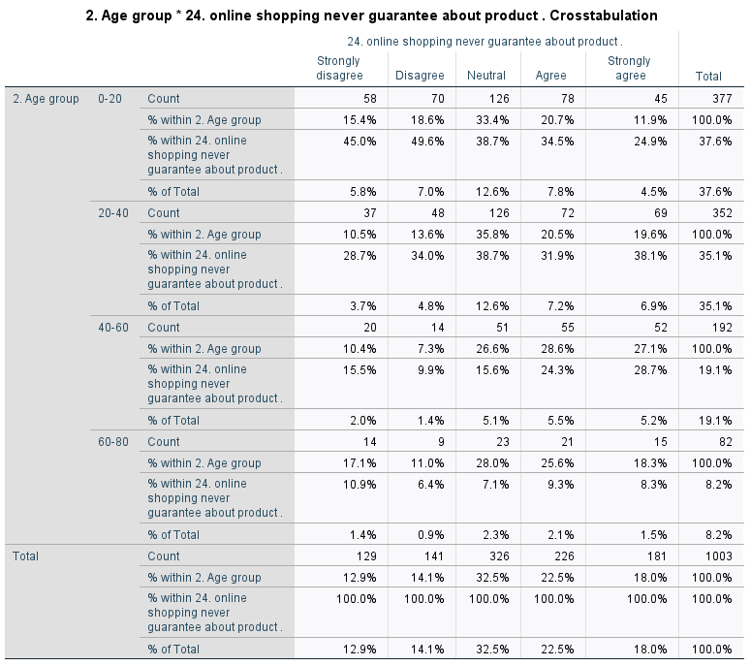

|  |  |  |  |
| --- | --- | --- | --- |
| **Chi-Square Tests** | | | |
|  | **Value** | **df** | **Asymptotic Significance (2-sided)** |
| Pearson Chi-Square | **43.299a** | **12** | **<.001** |
| Likelihood Ratio | **43.916** | **12** | **<.001** |
| Linear-by-Linear Association | **17.078** | **1** | **<.001** |
| N of Valid Cases | **1003** |  |  |
| a. 0 cells (0.0%) have expected count less than 5. The minimum expected count is 10.55. | | | |

Here from the above test we observe that the calculated value is 43.299 for 12df. The p value is 0.001 which is less than the significance value. Hence we accept alternative hypothesis, i.e. All the age group people may not have equal opinions.

* **Which marketing is more effective?**

Here we will get to know that which marketing is more effective for the people.

**NULL HYPOTHESIS:** All the age group people may select same marketing.

**ALTERNATIVE HYPOTHESIS:** All the age group people may not select same marketing.

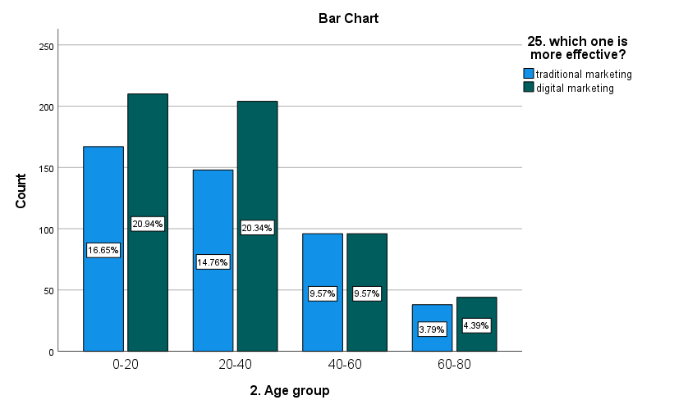

Here from the above table we can observe that most of the people i.e. 55.2% of them selected option as digital marketing, and 44.8% have selected traditional marketing. From this table we can conclude that digital marketing is more effective than traditional marketing.

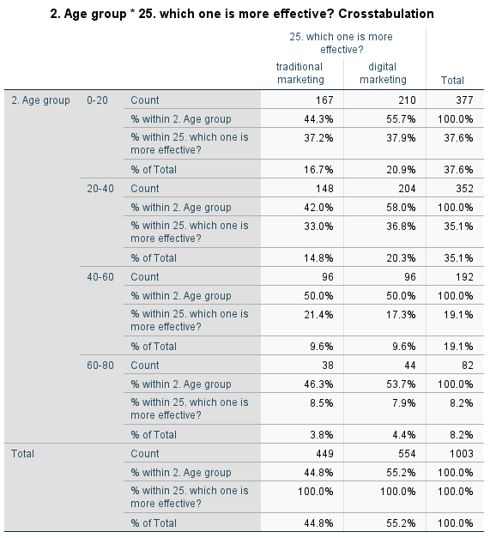

|  |  |  |  |
| --- | --- | --- | --- |
| **Chi-Square Tests** | | | |
|  | Value | df | Asymptotic Significance (2-sided) |
| Pearson Chi-Square | **3.297a** | **3** | **.348** |
| Likelihood Ratio | **3.289** | **3** | **.349** |
| Linear-by-Linear Association | **.935** | **1** | **.334** |
| N of Valid Cases | **1003** |  |  |
| a. 0 cells (0.0%) have expected count less than 5. The minimum expected count is 36.71. | | | |

Here from the above table we can observe that the calculated value is 3.297 for 3df. The p value is 0.348 which is less than the significance value. Hence we accept alternative hypothesis i.e. All the age group people may not select same marketing.

**CHAPTER – 5**

**SUMMARY EXECUTIVE**

* Our survey is a collection of data from people belonging to different age groups i.e., 0-20, 20-40, 40-60 and 60-80 regarding Traditional marketing vs Digital marketing.
* The survey shows that 37.59% of responds are from the age group of 0-20
* The survey shows that 35.09%of responds are from the age group 20-40
* The survey shows that 19.14% of responds are from the age group of 40-60
* The survey shows that 8.18% of responds are from the age group of 60-80

**TRADITIONAL MARKETING**

In past days Traditional marketing was more preferable because in this marketing the customer can check the quality of the product in different shops for comparing, and have a liberty to check and try the products, not only checking but also to find the products which are in their budget, and we can pay cash to the producer. In this marketing there is no scope for money scams and everyone can get the product which they like without any damage.

There will not be any fraud because it is direct contact and everything will be in between the producer and customer. If there is any problem in the product the customer can directly go to the shop and exchange the product.

**DIGITAL MARKETING**

Now a day’s Digital marketing is the most preferable shopping source because it saves the time, less leg work, and we can order a product where ever we wish at any time and also there are more number of variety to follow the trend but on the other hand there is a lot of fear for security issue, tangibility of the product (to feel the product and hold the product in hand before buying), but there are still trust issues in online shopping.

The young generation are more often purchasing from online sites because of the revolution in the technology among the youngsters comparing with any other age groups. In this shopping criterion there are more options, choice and everyone can get products according to their budget and taste. There are also some problems in this type of marketing which are like product damage, delay in delivery, money scams and much more.

# **CHAPTER 6: RECOMMENDATIONS**

* + It is recommended to purchase the products from the offline shops by compare the prices in online.
  + It is recommended to take the bills before leaving the shops for return and exchange policies.
  + It is recommended that before purchasing any product in online check the details about the website. Never purchase any product from new website until you are not sure.
  + Always try to check whether cash on delivery is available or not if it is available then don’t enter your card details or any of your UPI id in the websites.
  + Always purchase from the known apps and check all the details of a product, read the reviews and also check the return and exchange policies.
  + By not sharing your and your card details you can secure yourself from money scams or any other frauds.

# **QUESTIONNAIRE**